**NATIONAL UNIVERSITY OF SCIENCE & TECHNOLOGY**



SCHOOL OF MECHANICAL & MANUFACTURING ENGINEERING

**FUNDAMENTAL OF PROGRAMMINGS**

**LAB MANUAL 7**

**NAME**: HAMZA SAIF

**CMS** ID:481070

**SEC**: ME-15©

**Lab Task:**

**TASK#1:** Take 10 integer inputs from user and store them in an array and print them on screen.

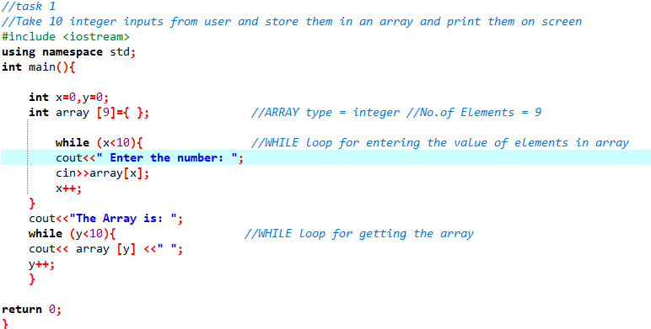

OUTPUT:

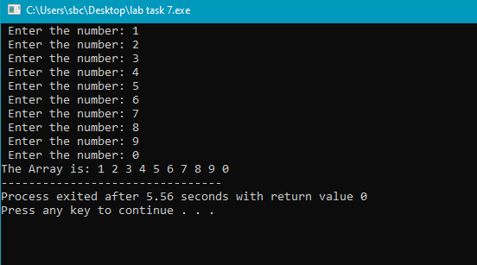

**TASK#2:** Write a program to find the sum and product of all elements of an array with 5 integer elements.

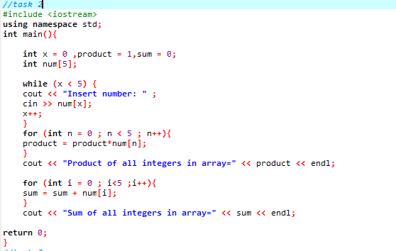

OUTPUT:

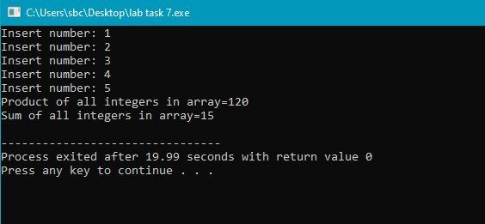

**TASK#3:** Print diamond pattern using a single array.

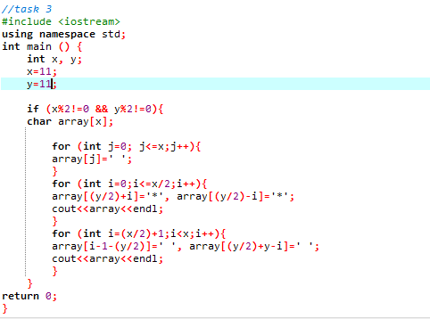

OUTPUT:

